ICT (Analysis)
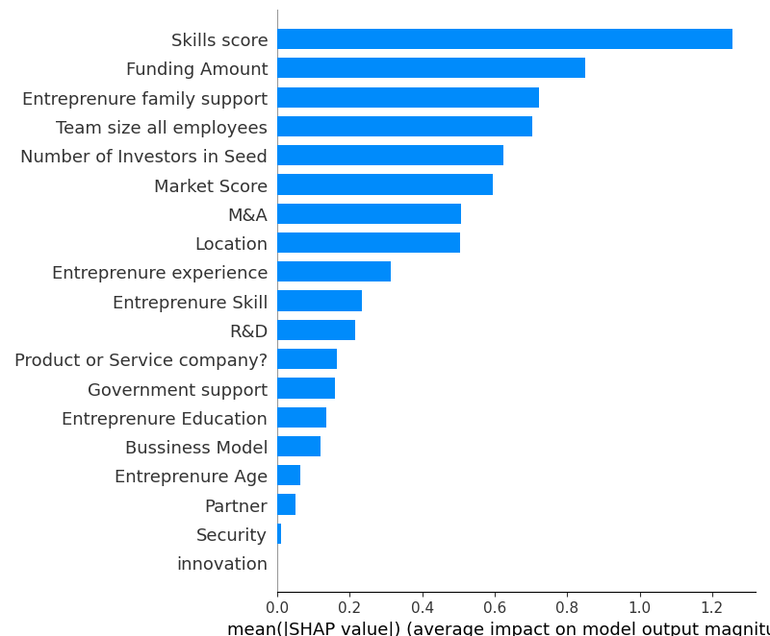

The values you provided appear to be Shap values for different dimensions or features in the context of evaluating the impact of these features on some target variable within the ICT (Information and Communication Technology) sector. Shap values are a way to understand the contribution of individual features to a model's predictions. Higher absolute Shap values indicate greater importance in predicting the target variable.

Let's analyze these Shap values in more detail:

1. **Skill (1.257):** Skill appears to have the highest positive impact on the target variable. This suggests that individuals with high skill levels in the ICT sector are more likely to contribute positively to the outcome you're interested in. This could mean that highly skilled professionals are more successful or generate better results.

2. **Funding Amount (0.846):** Funding amount also has a positive impact on the target variable. This indicates that having a higher level of funding can lead to better outcomes within the ICT sector. Adequate financial resources can fuel growth and development.

3. **Entrepreneur Family Support (0.720):** Family support for entrepreneurs has a positive impact, though not as strong as skill or funding. This suggests that having a supportive family can be beneficial for entrepreneurs in the ICT sector.

4. **Team Size (0.702):** A larger team size positively impacts the target variable. This could mean that companies or projects with more team members tend to perform better or achieve higher success rates.

5. **Number of Investors in Seed (0.602):** Having a greater number of investors during the seed stage of a venture also has a positive impact. This implies that more investors may lead to better outcomes for startups in the ICT sector.

6. **Market Score (0.593):** A high market score positively influences the target variable. This suggests that ventures operating in markets with favorable conditions tend to perform better.

7. **Marketing and Advertisement (0.506):** Effective marketing and advertising efforts have a positive impact. This underscores the importance of promoting products or services in the ICT sector.

8. **Location (0.504):** Location's impact is positive, indicating that the geographical location of a venture can influence its success within the ICT sector.

9. **Entrepreneur Experience (0.311):** Entrepreneurial experience also has a positive impact, but it's not as strong as some other factors. This suggests that prior experience in entrepreneurship can be advantageous but may not be as critical as skill or funding.

10. **Entrepreneur Skill (0.231):** Entrepreneurial skill is important but ranks lower in importance compared to some other factors.

11. **Research and Development (0.213):** Investment in research and development positively influences the outcome. This highlights the significance of innovation within the ICT sector.

12. **Product or Service Quality (0.162):** The quality of the product or service offered by the venture has a positive impact.

13. **Government Support (0.157):** Government support is beneficial, albeit less influential compared to other factors. Government policies and incentives can still play a role in the success of ICT ventures.

14. **Entrepreneur Education (0.135):** Entrepreneurial education is positively associated with the target variable but ranks lower in importance.

15. **Business Model (0.117):** The chosen business model has a positive impact, albeit relatively weaker than other factors.

16. **Entrepreneur Age (0.060):** Entrepreneurial age has a positive impact, although it's one of the weaker factors.

17. **Partnerships (0.049):** Having partnerships also contributes positively, but to a lesser extent.

18. **Security (0.009):** Security's impact is almost negligible, suggesting that it has minimal influence on the outcome within the ICT sector.

19. **Innovation (0):** Innovation has no apparent impact, at least according to the Shap values in this analysis. However, this result should be interpreted cautiously, as innovation is often a crucial factor in the ICT sector, and it could be that the model used for this analysis did not capture its importance accurately.

In summary, this analysis suggests that skills, funding, family support, team size, and the number of investors in the seed stage are the most influential factors in predicting success within the ICT sector. These findings can inform decision-making for entrepreneurs and investors in this industry. However, it's important to remember that the specific importance of these factors can vary depending on the context and the dataset used to generate these Shap values.

Skill Score
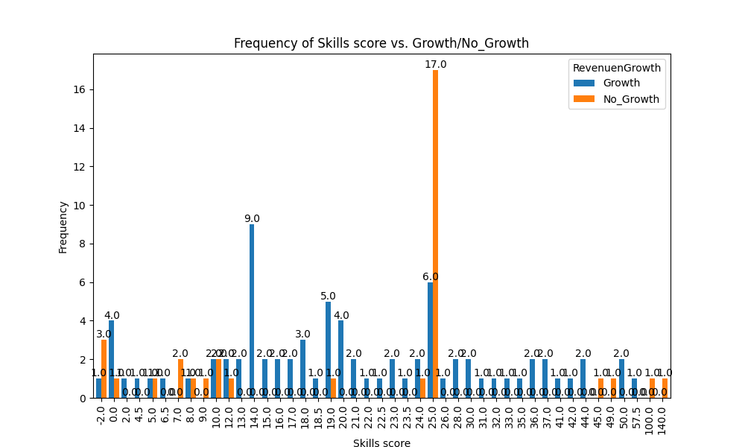

The requirement for a skill score greater than 13 for revenue growth in the ICT sector was noted. However, a specific exception was observed when the skill score reached 25, resulting in 17 out of the 23 companies experiencing no revenue growth. Upon analyzing these 17 companies, a common factor was identified: they all belonged to the service sector. It's important to highlight that not all companies in the service sector faced this issue, indicating that there is no singular clear reason for this exception.
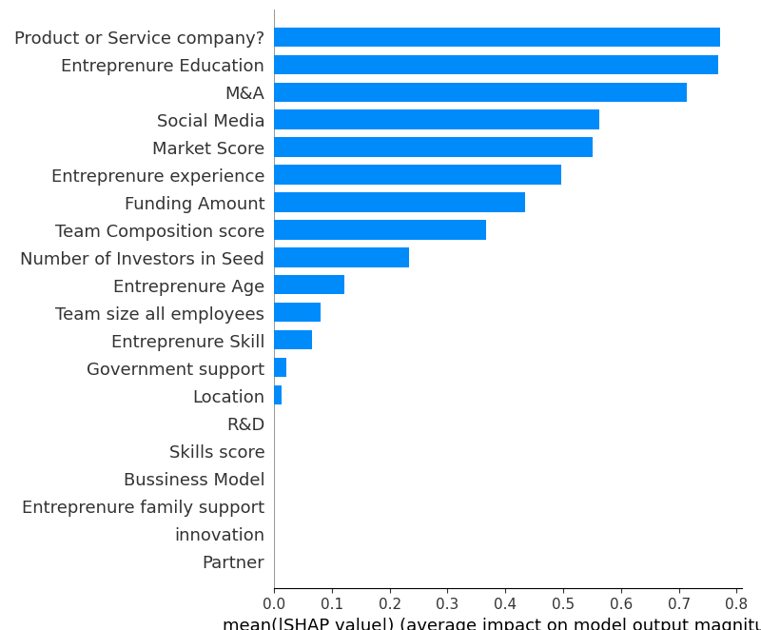

Further analysis was conducted by calculating the Shap values for these 23 companies to find some trends. The results revealed that within this group, the "product or service" dimension had the maximum positive Shap value, followed by "entrepreneur education" and "marketing and advertisement."

These findings suggest that, while the service sector as a whole did not guarantee revenue growth for these companies with a skill score of 25, there may be specific factors within this sector that influence success. In particular, the positive Shap values for "product or service," "entrepreneur education," and "marketing and advertisement" indicate that focusing on product or service quality, entrepreneur education, and effective marketing and advertising strategies may be key to overcoming the challenges faced by these 17 companies and help them achieve growth within the service sector.

Entrepreneur family support
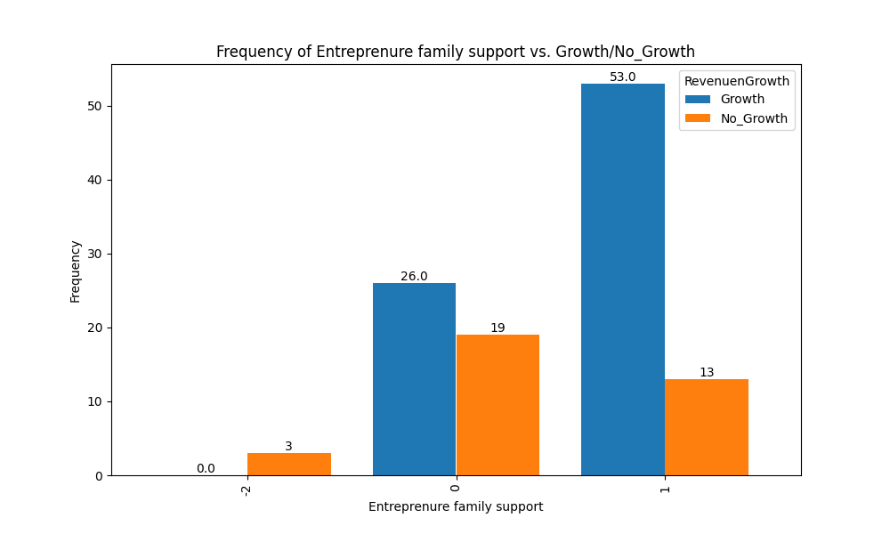

The data reveals a noteworthy disparity in revenue growth outcomes based on the presence or absence of family support within companies:

1. **With Family Support:**
- An impressive 80% of companies that benefit from family support experience revenue growth. This substantial success rate suggests that familial backing serves as a significant catalyst for financial growth.

- However, it's crucial to note that even with family support, 20% of companies do not achieve revenue growth. This minority highlights the fact that while family support is beneficial, it is not a guarantee of success, and other factors may come into play.

2. **Without Family Support:**
- In contrast, 57% of companies without family support still manage to achieve revenue growth. This demonstrates that success is possible in the absence of familial involvement, but the rate is notably lower.

- Nevertheless, a significant 43% of companies without family support do not experience revenue growth. This suggests that the absence of family support can indeed pose challenges for a considerable portion of these businesses.

3. **Overall Success Rates:**
- When looking at the overall success rates across all companies, it becomes evident that family support plays a pivotal role. A notable 53% of companies succeed when they have family support, signifying that this factor substantially increases the likelihood of revenue growth.

- In contrast, only 23% of companies succeed without family support, underscoring the considerable disadvantage faced by businesses lacking this type of support.

In conclusion, a critical analysis of the data underscores the pivotal role of family support in the success of companies, as it significantly boosts the chances of revenue growth. However, it's essential to acknowledge that other variables may influence outcomes, and even with family support, success is not guaranteed for every company. Nonetheless, the data clearly highlights the importance of familial involvement as a key driver of business success.

Density plot for government support vs family support

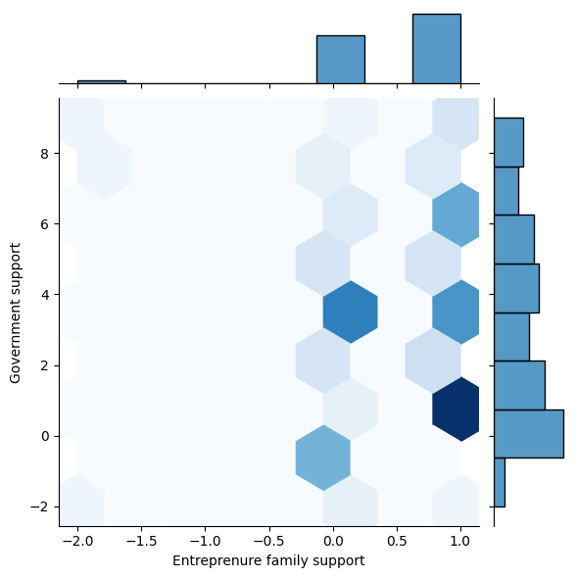
The hexbin plot comparing government support and family support reveals an interesting pattern. It suggests that companies with family support or those with an entrepreneurial background tend not to rely heavily on government support. Conversely, companies without family support appear to show a tendency to seek government support.

This observation highlights a potential relationship between familial or entrepreneurial support networks and the need for government assistance within the dataset. Companies with family support or entrepreneurial backgrounds may have alternative sources of support or resources, leading to a reduced reliance on government assistance.

On the other hand, companies lacking family support may be more inclined to seek government support as a means of compensating for the absence of other support networks.

Team Size
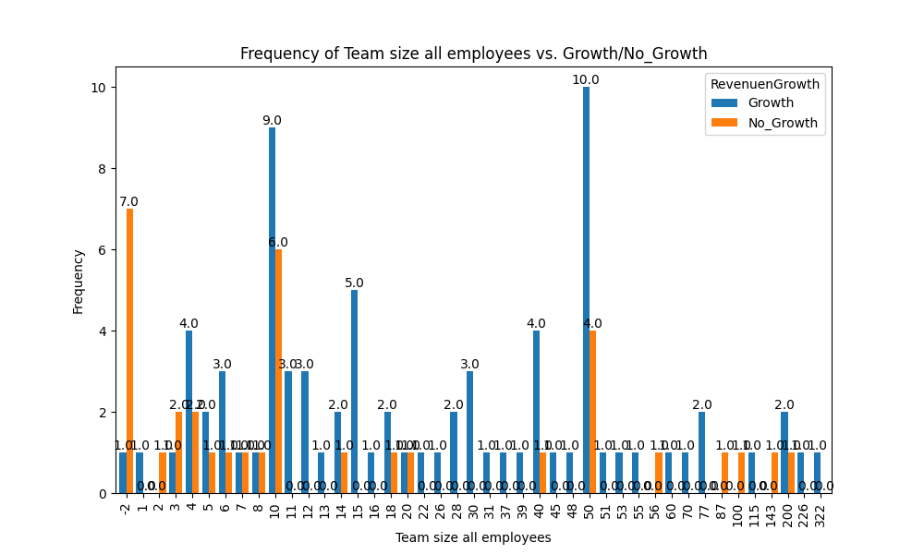

In the graph, a noticeable trend emerges as the team size increases beyond 10. Specifically, the frequency of orange bars decreases in this range. This observation suggests that there may be a correlation between team size and success.

It can be inferred that having a team size greater than 10 might be associated with a higher likelihood of success. However, it's important to note that correlation does not imply causation. While the data suggests a potential relationship, other factors could be at play, and further analysis is needed to establish a causal link between team size and success.

To delve deeper into this relationship and assess potential interactions with other variables, we will conduct a more detailed analysis using pair plots. Pair plots allow for visualizing multiple variables simultaneously, making it possible to uncover patterns and correlations that may not be immediately apparent in individual data points. By examining pair plots, we can explore how team size interacts with various other factors and how these interactions influence the likelihood of success. This comprehensive analysis will help us gain deeper insights into the dynamics at play within the dataset and better assess the impact of team size on the outcomes in question. Incorporating pair plots into the analysis is a valuable step towards a more comprehensive understanding of the data and its underlying trends.

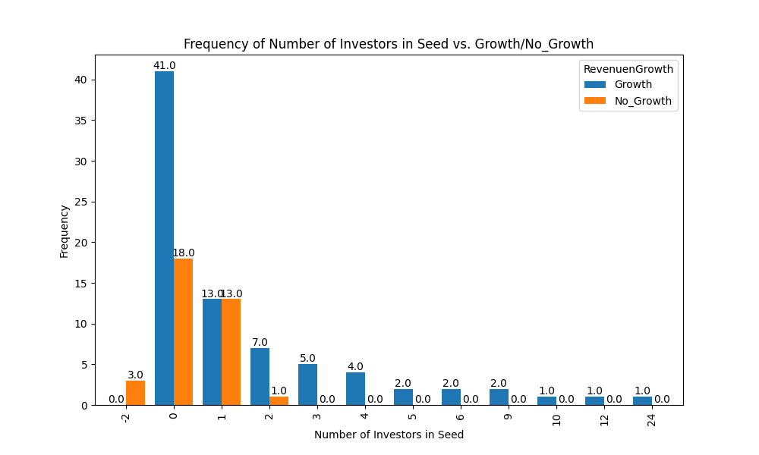
No of investors in seed

In the graph, a noticeable trend emerges as the team size increases beyond 10. Specifically, the frequency of orange bars decreases in this range. This observation suggests that there may be a correlation between team size and success.

It can be inferred that having a team size greater than 10 might be associated with a higher likelihood of success. However, it's important to note that correlation does not imply causation. While the data suggests a potential relationship, other factors could be at play, and further analysis is needed to establish a causal link between team size and success.

To delve deeper into this relationship and assess potential interactions with other variables, we will conduct a more detailed analysis using pair plots. Pair plots allow for visualizing multiple variables simultaneously, making it possible to uncover patterns and correlations that may not be immediately apparent in individual data points. By examining pair plots, we can explore how team size interacts with various other factors and how these interactions influence the likelihood of success. This comprehensive analysis will help us gain deeper insights into the dynamics at play within the dataset and better assess the impact of team size on the outcomes in question. Incorporating pair plots into the analysis is a valuable step towards a more comprehensive understanding of the data and its underlying trends.

Marketing and advertisement

The x-axis of the graph is divided into four categories based on whether the company requires marketing and whether they have done marketing:

-2: Companies for which no data was present.
-1: Companies that do not require marketing.
0: Companies that require marketing but have not done it.
1: Companies that require marketing and have done it.

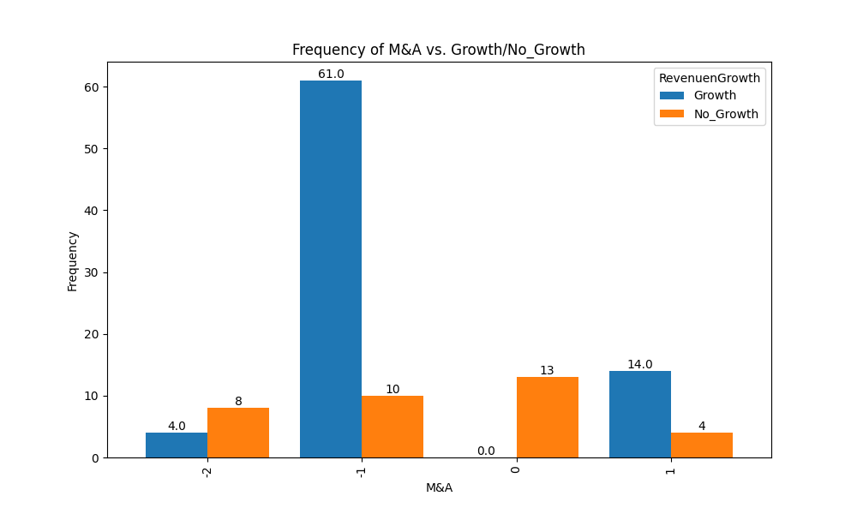

A study was conducted to determine the impact of marketing on revenue growth. The results showed that companies that required marketing but did not do it experienced no revenue growth. In contrast, companies that required marketing and did it saw revenue growth of 77%. However, even among companies that did marketing, 22% still saw no revenue growth.

These findings suggest that marketing is a crucial factor for companies to see revenue growth when they require it. However, it is important to note that marketing is not a guarantee of revenue growth. There are many other factors that can contribute to a company's revenue growth, such as the quality of the product or service, the pricing strategy, and the competitive landscape.

The study also found that the rate of revenue growth was higher for companies that had a clear marketing strategy and that executed their campaigns effectively. Additionally, companies that were able to adapt their marketing strategies to changes in the market were more likely to see revenue growth.

These findings provide valuable insights for businesses that are considering marketing. By understanding the factors that contribute to marketing success, businesses can increase their chances of achieving their revenue growth goals.

Location

- 1-Global
- 0-Local

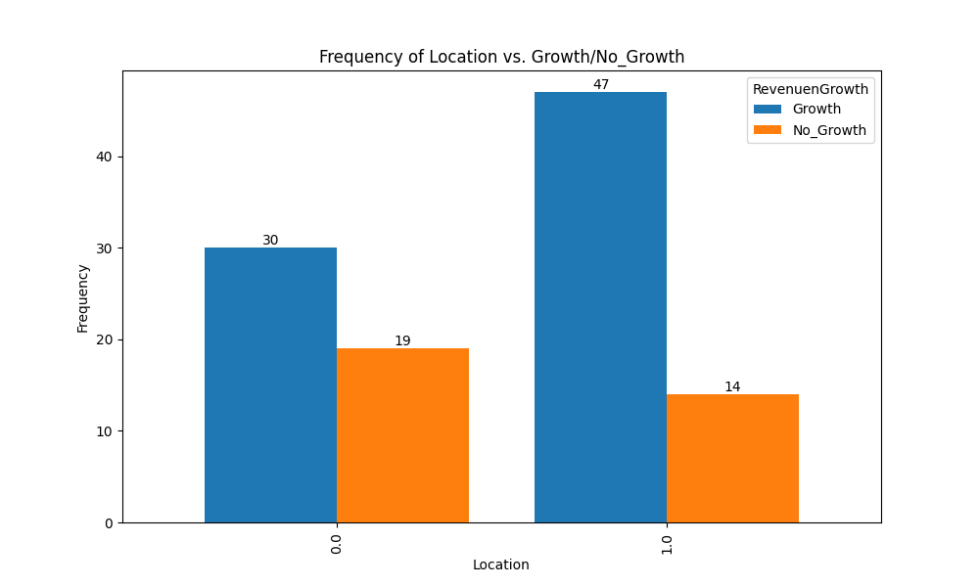
Operating Globally Gives an Edge for Revenue Growth. A study of companies that showed revenue growth found that 61% of them were operating globally. The percentage of revenue growth among global companies was 77%, compared to 61% for local companies. This suggests that operating globally gives a company an edge for revenue growth. There are a few possible reasons for this. First, global companies have access to a larger pool of potential customers. This is because they can sell their products or services to people in multiple countries. Second, global companies can spread their risk across multiple markets. This means that if one market is doing poorly, the company can still make money in other markets. Third, global companies can benefit from economies of scale. This means that they can produce their products or services more cheaply because they are buying in bulk. Fourth, global companies can learn from the best practices of other companies in different markets. This can help them improve their own operations. Of course, there are also challenges associated with operating globally. These include the need to adapt to different cultures and regulations, and the need to manage a complex supply chain. However, the potential rewards can be significant. If you are considering expanding your business globally, I would encourage you to do your research and carefully plan your strategy. With careful planning, you can increase your chances of success.

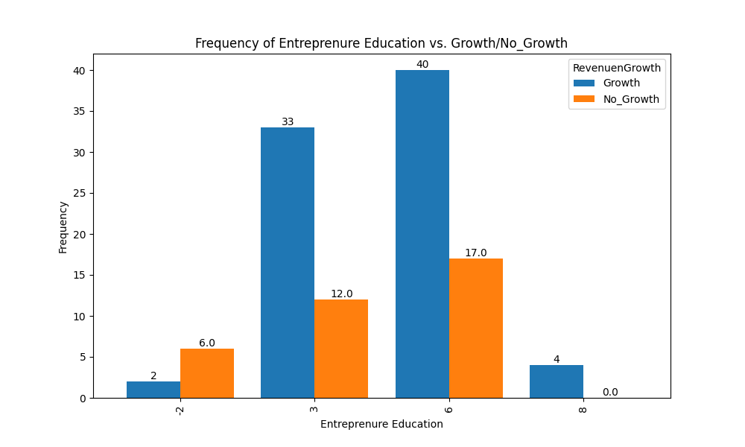
- Entrepreneur Education

While it's a common assumption that higher levels of education can be correlated with increased success, especially in entrepreneurship, it's important to note that success in entrepreneurship is influenced by a wide range of factors. These factors can include not only the entrepreneur's level of education but also their skills, experience, industry knowledge, access to resources, market conditions, and more.

It's also crucial to remember that correlation does not imply causation. Even if a graph shows a positive correlation between higher qualifications and revenue growth, it doesn't necessarily mean that obtaining a higher degree directly causes increased success in entrepreneurship.

Many successful entrepreneurs have achieved great success with a bachelor's degree or even without a college degree, relying on factors such as innovation, determination, networking, and adaptability. Conversely, having advanced degrees doesn't guarantee success in entrepreneurship, as other factors may come into play, including the opportunity cost of spending years in academia instead of gaining practical experience in the business world.

In summary, while there may be a correlation between higher qualifications and success in entrepreneurship, it's essential to consider a broader range of factors and not make sweeping generalizations based solely on education levels. Success in entrepreneurship is a complex interplay of various factors, and individual circumstances can vary greatly.
Business Model density plot
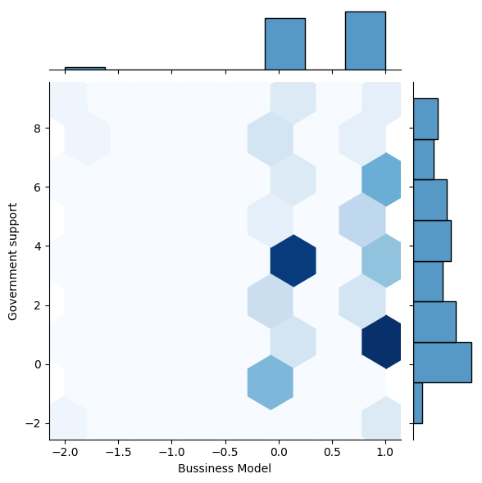
The data suggests an interesting trend: companies without a business model tend to rely more on government support, while those with a business model tend to rely less on government assistance. This pattern highlights the potential importance of having a well-defined business model in reducing the need for external support.

Companies that have a clear business model likely have a structured plan for generating revenue and sustaining their operations. As a result, they may have fewer dependencies on government support to fund their activities.

In contrast, companies without a business model may lack a clear path to revenue generation, making them more inclined to seek government support to bridge funding gaps and support their operations.

This observation underscores the significance of developing a robust business model as a strategic approach for reducing reliance on external support, such as government assistance, and increasing the self-sustainability of companies. However, it's important to consider that various other factors may also influence the need for government support, and further analysis may provide a more comprehensive understanding of these dynamics.

